logo2logo

Contents

1. Project description: 3

1.1 Project Background 3

1.2 Project Objectives 6

2. Model and feasibility analysis 6

2.1 Feasibility analysis 6

2.2 The AHP model of Delphi method 8

2.2.1 Delphi method 8

2.2.2 AHP Analytic Hierarchy Process 8

2.3 Normal Fuzzy Neural Network (NFNN) 9

2.4 Model building 10

3 Software technology 14

3.1 Environment configuration and technical details 14

3.1.1 Overview 14

3.1.2 Technology and tools 14

3.1.3 Summary of technology 16

3.2 architecture design 18

4. Product introduction 18

4.1 Synopsis 18

4.2 Final product interface display 19

4.2.1 Human-Computer Interaction (HCI) standards 19

4.2.2 Interface display 21

4.3 functions 22

4.3.1. Information authentication 22

4.3.2 Credit assessment 23

4.4 Technical risk 23

5. Product SWOT analysis 24

5.1 Overview of SWOT methods 24

5.2 This product SWOT analysis 24

5.2.1 Strength 24

5.2.2Weakness 25

5.2.3Opportunity 25

5.2.4Threats 26

5.3 The Countermeasure of Perfecting the Credit Rating System of University Students' Credit 26

5.3.1Establish a sound network loan supervision system 26

5.3.2 User review and evaluation 26

5.3.3Gradually expand the university customer base 26

6. Market Expectation 27

7. Financial Forecast and Profit Analysis 29

7.1 Profit model 29

7.2 Major financial assumptions 29

7.3 Project Initial Capital Demand Forecast 30

7.4 Finance prediction 31

7.5 Forecast of income statement 33

7.6 Forecast cash flow statement 34

7.7 DuPont analysis 35

# 1. Project description:

Future Credit is intended for commercial banks to provide college students with credit rating, so that students can enjoy a better credit loan services. Through face recognition, bank cards binding and mobile phone number verification, etc., our product confirms the authenticity of the identity of users, so as to obtain multiple dimensions of data from the students, including natural features, school performance, economic level, external environment, to portrait the users. Meanwhile, in the use of large data, we apply fuzzy neural network algorithm for college student credit rating.

## 1.1 Project Background

1.1.1 College student credit consumption demand analysis

With the rapid development of China's economy in recent years, the concept of college students' consumption has undergone tremendous changes. The awareness of advance consumption has been enhanced, and the demand for credit consumption keeps ballooning sharply.

College students are a special group of consumers. Currently they are not working in the society and lack stable source of income. They can be misled easily due to their immature nature which may change their life. According to some data, recently students have more and more expense with greater need for loan. We must take commercial and social factors into consideration since students are not mature enough.

1.1.2 Credit situation of college students

College students still have the problem of high default rate, mainly because the credit record of college students has not yet formed, the credit consciousness of college students is weak, even if the default will not affect the individual credit, but also lack of reasonable credit rating system for college students.

As a result, online loan platforms are led to an important position in the credit market, especially in the credit consumer market. Because of the convenience and efficiency of the online loan system, in current society which is characterized by market economy hustle and bustle and fast-paced life, students who need money rush to these platforms. Nonetheless, lacking deliberate analysis of the cost of loans and their own afford ability, many students finally find it difficult to get out of debt.

So we need a set of credit evaluation system for college students to conduct a comprehensive evaluation to college students credit, especially the loan credit, so as to reasonably avoid risks, guide students to develop financial quotient and cherish credit.

1.1.3 Big data credit

With the extensive application of large data technology in the financial field, large data credit has received more and more attention. The large data credit information is mainly through the mass, scattered, diversified, with a certain value of the data for rapid collection, analysis, mining, the use of machine learning model algorithm multi-dimensional characterization of credit defaults and credit status. Large data credit from its essence is the application of large data technology to credit activities, highlighting the large number of data processing, characterization of credit dimensions, the dynamic status of credit, interactive and other characteristics of these activities Does not exceed the "credit management regulations," as defined in the scope of credit business, in essence, is still the collection, collation, preservation, processing and publication, is only around the large data 4V characteristics (Volume large, Velocity High speed, Variety variety, Value value), in a new way, a new perspective to carry out.

At present, China's credit system data is mainly from a variety of financial institutions and public institutions. Traditional credit model, in spite of its high authority, often face many problems , such as incomplete credit information, low object coverage, low upload data initiative , not timely update large data. However, the credit model based on big data, having a wide range of data sources, makes up for the deficiencies of traditional credit. Data types, not limited to credit data, diversifies and more fully reflect the personal credit situation.

1.1.4 Campus loan events frequently

In the past two years, "naked loans" and some other school loans led to endless vicious news. The reason can be analyzed from the following three dimensions:

First, the front desk marketing misleadingly. Online loan platforms usually use the "low interest" words to attract college students, but in fact, online loan platforms calculate the monthly interest basing on the initial loan amount , which is often twice of bank interest. Part of the online loan achieve main profit channels all by the so-called service fees category, some unscrupulous network loan platform, in order to achieve the contract breach of contract and late payment conditions, even deliberately set cumbersome early repayment conditions, and do not fulfill the obligation to inform, not remind overdue. Part of the campus loan invisible annual interest rate even reaches 70%.

Second, the risk control in middle desk is almost dummy. Not only too low in the information collection of the front desk the net loan platform requires, the auditor also does not verify the authenticity of the borrower's identity and does not monitor or restrict the borrower's purpose in the credit process, lacking risk identification, quantification and monitoring.

Finally, due to the lack of effective risk control system, in order to reduce bad debts, all risk control is usually realized in the loan collection. Moreover, the collection process is often accompanied by intimidation and threats, including the arrears of student private information open, threaten violence to door, etc., resulting in adverse social impact.

1.1.5 Policy Background

According to the latest Notice on Further Strengthening the Management of Campus Credit, the Ministry of Education, the Ministry of Education and the Ministry of Human Resources and Social Security on June 28, 2017 (No. 20 [2017] No. 26), any network lending institutions do not allow loans to college students. At this stage, all network loan institutions are suspended from carrying out college student network loan business, and gradually end their business.

At the same time, the "notice" also mentioned: to meet the college students in the consumer, entrepreneurship, training and other aspects of reasonable credit and financial service needs, commercial banks and policy banks should, assuring risk under control, develop financial products that help college students with training, consumption and so on. By providing students with customized and standardized financial services, setting reasonable credit quota and interest rates, the quality of college student loan service can be improved, and sunshine campus credit service channels can be realized.

1.1.6 Future Orientation

Banks, as traditional financial services institutions, should gain a place in the credit market of college students, shoulder the responsibility of standardizing the credit market of college students and strive to build a good credit market for college students. Traditional commercial banks have significant advantages, and higher social recognition in terms of standard management. They are more likely to be accepted by college students, parents, schools and supervisors. Banks can cooperate directly with universities. Commercial banks have a more standardized and effective risk assessment and control means.

Colleges should also assume the moral education, ideological and moral education, mental health education responsibility, concerned about the student credit situation, to guide students to develop financial quotient, cherish credit, and work with banks to improve the credit environment of college students. The advantage of college lies in mastering the vast majority of structured, unstructured information that can provide strong data support for credit ratings.

## 1.2 Project Objectives

This application will focus on collecting the necessary information available from the public and the user's own upload, comprehensively assess the credit status of college students as lenders, effectively alleviate the asymmetry of college students' loans and commercial bank loans, and encourage the rational use of college students Loans. What our application mainly do is on one hand launching strict supervision of its use and control of default risk, on the other hand providing commercial banks with credit reference certificate with which can commercial banks carry out their loans for college students business.

At the same time, what the students of the loan activities must take into account are the investment profit and social orientation. To solve the urgent needs of college students as well as to effectively control the risk, we do not raise or issue loans, but pay attention to the effective assessment of credit of college students, play the role of information intermediaries, and set up a bridge between college students and formal commercial banks.

The traditional college students' credit evaluation model only uses the structured data to carry on the static evaluation. On this basis, our project intends to use AHP analytic hierarchy process, Delphi method, and fuzzy neural network method to carry out a comprehensive portrait of college students.

# 2. Model and feasibility analysis

## 2.1 Feasibility analysis

Both of neural network and fuzzy logic have pros and cons.

There are mainly 2 advantages for neural network. First, it has the capability of learning and self-adaption. Second, it can do parallel processing and has quite strong capacity of fault-tolerant. However, it has obvious deficiencies in terms of knowledge expression and the interpretation of the rules that are learned from study.

Meanwhile, there are also 2 advantages for fuzzy logic. First, it can express knowledge naturally and easily, which can be used to handle uncertain information. In this case, we can use fuzzy natural language to express knowledge and we can take advantage of experts’ experience quite easily. Second, we can use single calculation to achieve fuzzy inference. But the learning ability of fuzzy logic is quite weak, which leads to the weakness of knowledge acquisition. So fuzzy logic is more likely to be a pure statistical regression model.

Fuzzy neural network is the combination of fuzzy logic and neural network. This combination can offset both the deficiency of neural network in terms of fuzzy data processing and the weakness of pure fuzzy logic in terms of study. Meanwhile, fuzzy neural network lets neural network, a ‘Black-box’ problem, be more transparent. In other word, we can use the input and output relation of fuzzy neural network to achieve many causal relationships that are described by rules.

We intend to set up a credit scoring system, a problem belongs to financial field, which has a sophisticated economics knowledge system. If we use the traditional neural network model, then it will be a pure regression model to a great extent and hardly have connection with economics. What’s more, influencing factors such as redundant data and inappropriate samples may lead to a large deviation between regression result and the actual situation. Bringing in fuzzy logic can solve this problem smoothly. Fuzzy logic has a decent application of financial knowledge and has a clear logic structure, which avoids the system error brought by redundant data or other irrelevant factors.

What’s more, the credit evaluation indexes we chose, such as students’ natural condition and economic level, are all abstract concepts and have no intuitional mathematical expressions. We can select some main indexes to be the representative and then digitize them. But based on this, we can use fuzzy sets to distinguish the good and bad of the indexes, which is undoubtedly a better process mode. In fact, this is just what we do at the first 3 layers (input layer, fuzzifying layer and regularizing layer) of our regularized fuzzy neural network.

Therefore, our regularized fuzzy neural network has a decent application of economics knowledge. At the same time, fuzzifying the input data can also weaken the influence of irrelevant factors, which brings our model an economic meaning besides statistic meaning. The characteristic of this network model is that, when we exactly know the in-out mode and the number of functions in the fuzzifying layer, we can confirm the node number of fuzzifying layer, regularizing layer and rule layer by calculation. Generally, neural network hardly has strict design rules for network topology. What’s more, there’s no rule about the layer number of network and the node number of each layer and we just set those numbers by experience. Our fuzzy neural network model can avoid these 2 drawbacks.

Practices have proven that regularized fuzzy neural network has a vital application value in reality, especially in terms of expert system representation and pattern recognition. Obviously, credit rating is a kind of pattern recognition problem, which can be solved smoothly by NFNN.

In conclusion, we decide to use NFNN to do the credit model evaluation for college students.

## 2.2 The AHP model of Delphi method

### 2.2.1 Delphi method

Delphi method, also known as the expert investigation method, is the use of back-to-back communication to consult the members of the expert group of predictive opinions, after several rounds of consultation, so that the expert group's forecasting tends to be concentrated . Thereby ,according to expert opinion on the evaluation object , qualitative and quantitative combination of predictions and evaluations could be made . By calculating the importance of the indicators, the full rate, the coefficient of variation, the positive coefficient of expert advice, the authority coefficient of the expert and the coordination coefficient of the expert opinion, we can test the degree of concentration, reliability, authority and coordination of the expert consultation.

### 2.2.2 AHP Analytic Hierarchy Process

Analytic Hierarchy Process (AHP) is an easy way to make decisions about some of the more complex and vague problems, and it is particularly useful for problems that are difficult to fully quantify. It is a simple, flexible and practical multi-criteria decision-making method by Professor T. L. Saaty , an American operational scientist, in the early 1970s. The use of analytic hierarchy process modeling, in general, the following four steps:

(i) the establishment of a hierarchical hierarchy model;

(Ii) construct all the judgment matrices at each level;

(Iii) single order and consistency check;

(Iv) level total sort and consistency check.

Meaning of judgment matrix scale

|  |  |
| --- | --- |
| scale | meaning |
| 1 3 5 7 9 2，4，6，8  reciprocal | Said the two factors compared to having the same importance  Said the two factors compared to the former is slightly more important than the latter  Said the two factors compared to the former is significantly more important than the latter  Said the two factors compared to the former is more important than the latter  Said the two factors compared to the former is extremely important than the latter  Represents the intermediate value of the adjacent judgment  If the ratio of factor i to the importance of factor j is ,the ratio of factor j to factor i is . |

## 2.3 Normal Fuzzy Neural Network (NFNN)

The basic composition of regularized fuzzy neural network can be divided into five layers, namely, input layer, fuzzy layer, regularization layer, rule layer and anti-fuzzy output layer.

The training of the network modifies the fuzzy center, variance and the connection weight between rule layer and anti-fuzzy output layer..represents the membership function of the kth node of the input variable , and assume that has term nodes for fuzzy partitioning, That is, the number of fuzzy membership functions corresponding to the input variable is . The general NFNN structure as shown below:

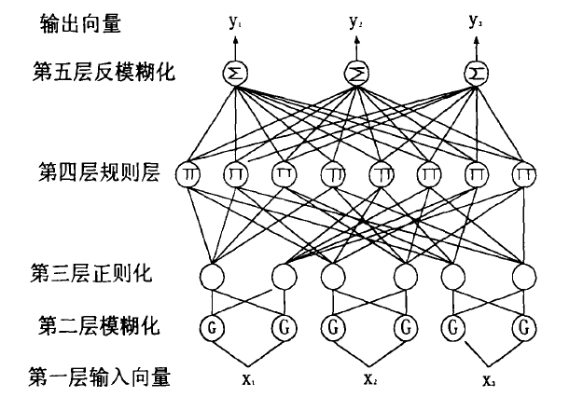

The layers in the NFNN structure are defined as follows:

The first layer: the input layer

This layer is responsible for the input of the NFNN. The input vector can be an exact value vector or a fuzzy quantity.

The second layer: the fuzzy layer

The layer uses the Gaussian function as a membership function to blur the non-ambiguous vector of the input layer input.

The third layer: the regularization layer

The layer operates on the output of the second layer, normalizing the output of the second layer.

The fourth layer: the rule layer

This layer connects the front (normalized node) and the conclusion node (output node).

The rules of the connection are:

The node is connected only to a regular node from each input component after blurring.

The fifth layer: the anti-fuzzy layer

All fourth-level rule nodes are connected to the layer output node. This layer completes the center average anti-fuzzification operation.

## 2.4 Model building

The traditional AHP model divides the evaluation objects into multiple levels, and compares the relative degree of the importance of the same level and compares the relative advantages and disadvantages of the same factors in different schemes, and finally selects the optimal scheme from the multiple schemes. We combine the core idea of the AHP model with the Delphi method to construct a multi-level scoring model. The hierarchical structure of AHP model is used to determine the weight ratio of each layer factor by Delphi method, and the consistency index CI in AHP model is used to check the consistency of single order and hierarchical ranking. By modifying repeatedly, the weight ratio of Delphi method tend to be accurate and reasonable.

In the end we get the following indicators and weights:

Table Ⅰ

|  |  |  |  |
| --- | --- | --- | --- |
| Second indicators | Third  indicators | Fourth  indicators | Final  weight |
| Repayment ability | Student natural features | Gender（X1）  Age（X2）  Education（X3） | 0.25  0.25  0.5 |
| Student performance in college | College（X4）  Faculty（X5）  GPA（X6）  Awards（X7） | 0.14  0.29  0.43  0.14 |
| Student economic level（Unit: thousand yuan） | Living expenses（X8）  Scholarships（X9）  Part time job（X10）  Electronic assets（X11） | 0.25  0.25  0.38  0.12 |
| Family（Unit: ten thousands yuan） | Family annual income（X12）  Per capita GDP（X13） | 0.75  0.25 |
| Repayment intention | External environment | 100* College default rate（X14）  Per capita breach of contract（thousand yuan）（X15） | 0.67  0.33 |
| Moral quality | Punish record（X16）  volunteer（X17） | 0.67  0.33 |
| Moral quality | Sesame credit（X18） | 1 |

Table Ⅱ

|  |  |  |  |  |  |
| --- | --- | --- | --- | --- | --- |
| indicators | Fuzzy indicators and credit rating specification | | | | |
| X1 | Male3 | Female 4 |  |  |  |
| X2 | 18-：-1 | 18-21：0 | 21+：1 |  |  |
| X3 | Ph.D. 4 | master 3 | Undergraduate 2 | Other 1 |  |
|  |  |  |  |  |  |
| X4 | 985 4 | 211 3 | tier-1 2 | Other 1 |  |
| X5 | Popular 6 | General 4 | unpopular 2 |  |  |
| X6 | excellent 9 | good 7 | medium 5 | worse 3 | bad 1 |
| X7 | School level 7 | fca 5 | sca 3 | tca 2 |  |
| X8 | True values | | | | |
| X9 |
| X10 |
| X11 |
|  |
| X12 |
| X13 |
|  |
| X14 |
| X15 |
| X16 | Warning：-1 | Demerits：-2 | Probation：-3 | Expel：-4 | Nothing：0 |
| X17 | Nothing：0 | 0-10：1 | 10-20：2 | 20+：3 |  |
| X18 | bad：-4 | medium：-2 | good：0 | excellent：2 | outstanding：4 |

1. data preprocessing

The format of each user data is as follows:

)

The meaning of each component is shown in Table 1.

A standard value is selected for each data item by the expert scoring method, and the obtained raw data is divided by the reference value to obtain normalized data so that different types of data at the same level can be weighted at the same level. This step is a preprocessing of the data that will be scored into the AHP model.

1. the input layer

Student natural features：

Student performance in college：

Student economic level：.25+0.25

Family：+0.25

External environment：=0.67+0.33

Moral quality：=0.67+0.33

Third party credit：=

The above seven indicators are scored for each user data, and these seven indicators will be used as input values for the NFNN model. The input data of the NFNN calculated above is written in the following vector form:

)

1. the fuzzy layer

For each index , we set two fuzzy sets of high() and low(), with the membership function in forms of the Gaussian function where is the center and is the standard deviation.

1. the regularization layer

The layer operates on the output of the second layer, normalizing the output of the second layer.

1. the rule layer

This layer connects the front (normalized node) and the conclusion node (output node). The rules of the connection are:The node is connected only to a regular node from each input component after blurring.

Let k be expressed as a 7-bit binary form，k=,for i=1,2…,7, or 1,then the value of can be defined correspondingly:

1. the anti-fuzzy layer

All fourth-level rule nodes are connected to the layer output node. This layer completes the center average anti-fuzzification operation.

1. Backward propagation algorithm

The backward propagation algorithm is used to calculate the parameter values.

# 3 Software technology

## 3.1 Environment configuration and technical details

### 3.1.1 Overview

The system uses Python, SQL language as the development language of the background server, which uses the Mysql database to store information. Meanwhile, the system uses JavaScript technology to develop the Web side. The communication module communicates over HTTP routes, and the information is encapsulated using the JSON definition.

In the development process, UML is applied for system design, Github management code, code correlationship and Github project are built for group information sharing. In addition, ProcessOn is applied for system modeling and architecture design.

### 3.1.2 Technology and tools

3.1.2.1 Python (core algorithm)

Python is an object-oriented, literal translation of computer programming language. It contains a complete set of functional standards library, which can easily complete a lot of common tasks. The Python community provides a large number of third-party modules that are similar to standard libraries. Their functions cover a number of areas of scientific computing, including Web development, database interfaces, and graphics systems. Python is often used as a "glue" language between other languages and tools.

3.1.2.2 Flask

Flask is a lightweight Web application framework written in Python, which is based on the Werkzeug WSGI toolbox and the Jinja2 template engine, using BSD authorization.

Flask is called "microframework" because it uses a simple kernel, with extensions to add other features. Flask does not have the default use of the database or the form validation tool. However, Flask retains the flexibility of amplification, you can use Flask-extension to add these features: ORM, form validation tools, file upload, and a variety of open authentication technology.

3.1.2.3 UML (Unified Modeling Language)

Unified Modeling Language (UML), also known as Unified Modeling Language or Standard Modeling Language, began with an OMG standard in 1997, is a graphical language that supports modeling and software system development. It providing models for all stages of software development and visual support, from requirements analysis to construction and configuration. UML was the product of object-oriented analysis and design methodology in the late 1980s and 1990s, which not only unifies Booch , Rumbaugh and Jacobson's representations, but also made further development and eventually unanimously accepted by the public Standard modeling language.

3.1.2.4 Web client

1. Ant Design

Ant Design is a set of enterprise-class UI design language and React implementation. With the interactive language and visual style of the enterprise mid-range products, the instant high-quality React components are built using TypeScript , providing complete type definition files, and characteristic by enterprise-based development framework which is based on npm + webpack + dva.

2.Dva

Dva is a lightweight front-end framework based on redux, redux-saga and react-router. Dva is easy to learn and use, elm concept, support mobile and react-native, support HMR, dynamic loading Model and routing, plug-in mechanism, perfect syntax analysis library dva-ast, support TypeScrip and so on.

3. Node.js

Node.js is an open source, cross-platform JavaScript runtime environment that can run JavaScript on the server side. Node.js is held and maintained by the Node.js Foundation and has a relationship with the Linux Foundation. Node.js uses Google-developed V8 to run code, together with event-driven, non-blocking, and asynchronous input-output models to improve performance and optimize application throughput and size. These techniques mentioned are typically used for data-intensive fact applications.

3.1.2.5 MySQL

MySQL is a small, relational database management system developed by the Swedish company MySQL AB, currently owned by Oracle. MySQL is an associated database management system that associates data in different tables rather than puts all the data in a large repository, thus increasing speed and increasing flexibility. MySQL's SQL language is the most commonly used standardized language for accessing the database. MySQL software uses the GPL (GNU General Public License), which is divided into free and commercial versions. Due to its small size, fast, low total cost of ownership, especially the feature of open source, the general development of small and medium-sized projects all select MySQL as the database.

3.1.2.6 Ali cloud

Tencent cloud computing (full name Tencent cloud computing (Beijing) limited liability company, referred to as Tencent cloud), to provide enterprises and individuals for the public cloud platform, is a industry solutions technology company which provides basic cloud computing services like cloud server, cloud database, cloud storage, CDN and so on, and provides WeChat , Games, and mobile application as well. It is wholly owned by Tencent Holdings Limited. Instituted in Shenzhen, Beijing and Chengdu, it researches and operates products, services and solutions related to cloud computing.

3.1.2.7 GitHub (software process management, version control)

GitHub is a powerful code base and distributed version control system. As more and more applications move to the cloud, GitHub has become the preferred method for managing software development and discovering existing code. The user can host the project code to GitHub and perform version iteration updates and branch merge.

### 3.1.3 Summary of technology

The server version as well as support the system environment and browser in this product are as follows:

Table 3.1.3-1 server version, support system environment and browser

|  |  |
| --- | --- |
| Server | Tencent cloud（Ubuntu IP:127.27.199.164 ） |
| Browser | Chrome／Firefox／IE10/Microsoft Edge |

Table 3.1.3-2 Framework

|  |  |
| --- | --- |
| Pyhton Flak | server support framework |
| dva | Web runtime framework |

Table 3.1.3-3 Environment Construction

|  |  |
| --- | --- |
| Windows10/MacOS | development environment |
| Mysql | Mysql server database |
| Python3.6 | server runtime environment |

Table 3.1.3-4 Programming Language

|  |  |
| --- | --- |
| Html／CSS／JavaScript | Web front end development language |
| Python | server development language |
| UML | Unified Modeling and Architecture Language |

Table 3.1.3-5 Tools

|  |  |
| --- | --- |
| Pycharm | Python Program Development IDE |
| WebStorm | Web Development IDE |
| Git | version control tool |

## 3.2 architecture design

3.2.1 Use case view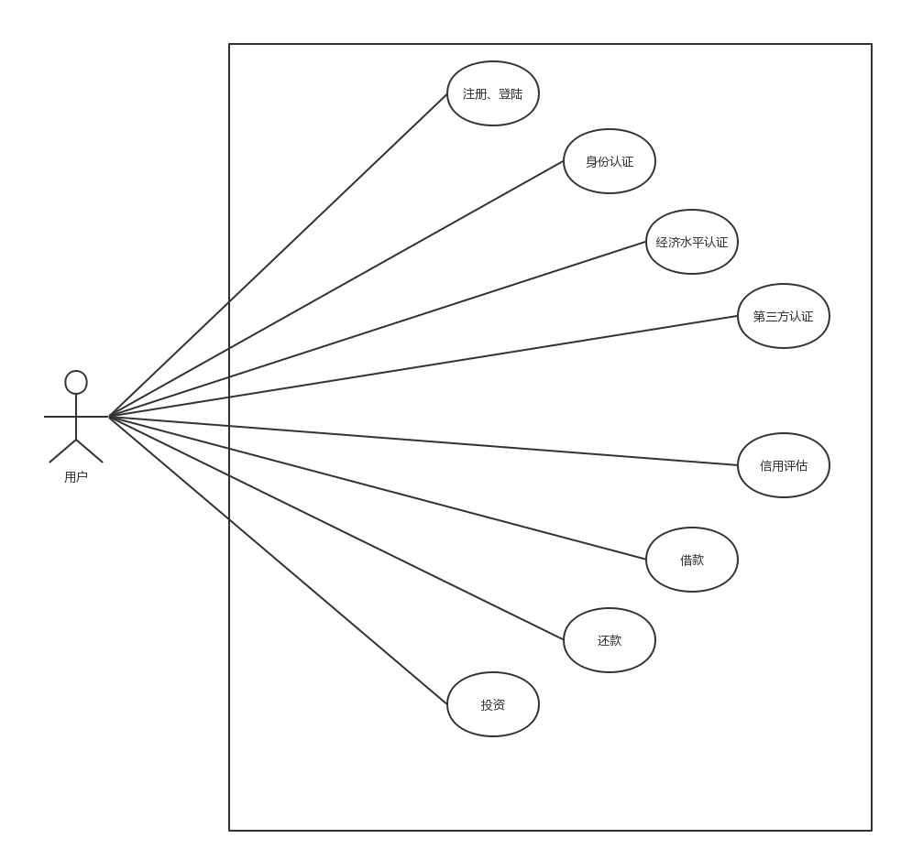

# 4. Product introduction

## 4.1 Synopsis

Currently our product collects the following information: their universities, majors, GPA, winning record, volunteer experience and duration, pay treasure sesame credit score, criminal record, disciplinary record, debt records, library default records, living expenses, Card consumption records, Alipay consumer records, part-time income, parental career and income levels, private ownership of electronic products, associated guarantor and so on. We collect this information entirely for the purpose of assessing credit in order to provide the most reliable reference to the bank, and for the private information uploaded to college students, we will take encryption measures to ensure the safety of these data. After collecting the information, our evaluation system will consider the different influence factors, give the corresponding weight, automatically calculate the user's credit assessment score, through the scores of the interval to determine its credit level to objectively predict their repayment ability to facilitate reference for commercial banks as much as possible.

Our main customers are commercial banks which are qualified for providing loans to college students. Commercial banks can use our platform to achieve investment profit. We provide specific credit rating to commercial banks, whether the bank itself decides whether to issue and how much loans to issue. University student repayment does not go through our platform and we are not responsible for the management of loans. Throughout the whole process, banks have the right to make decisions. We are mainly take part in the processing information and credit assessment and other aspects of the charges and profit. Our business model clear.

Although the current product is only on the web side, but with the gradual development of products, the number of users gradually increases, we will develop both iOS and Android App to facilitate more needs of college students to make our service more accessible to them, We will expand from one school to a number of schools, from a single commercial bank to all qualified commercial banks, and gradually occupy a larger market,.We will bring benefits to the society when making profits.

## 4.2 Final product interface display

Guide by function requirements, through the architecture design and prototype iterative process, the product interface eventually formed. Below, we first make a brief introduction to HCI, and then a detailed introduction of the use of the software under the Web.

### 4.2.1 Human-Computer Interaction (HCI) standards

4.2.1.1 Overview of human-computer interaction

HCI, Human-Computer Interaction, is a kind of human-computer interaction system principles about design, evaluation and implement.

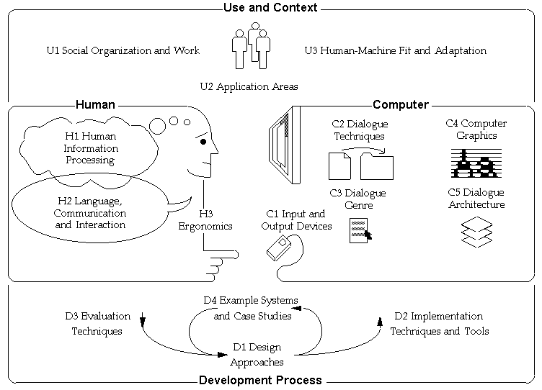

4.2.1.2 Human-computer interaction (HCI) processes and principles

In our product design activities, human-computer interaction mainly satisfies the following characteristics.

Purpose: The user can complete the corresponding function by clicking on the screen.

Consistency: The overall style of the page is consistent, allowing the user to experience any of the functions in a consistent way.

Timely feedback: the user's all operations will be feedback, so that the user will have a full understanding and awareness of their own operation.

Aesthetics: the layout of all the pages, fonts and colors makes the page look not boring monotonous but professional.

4.2.2 Interface display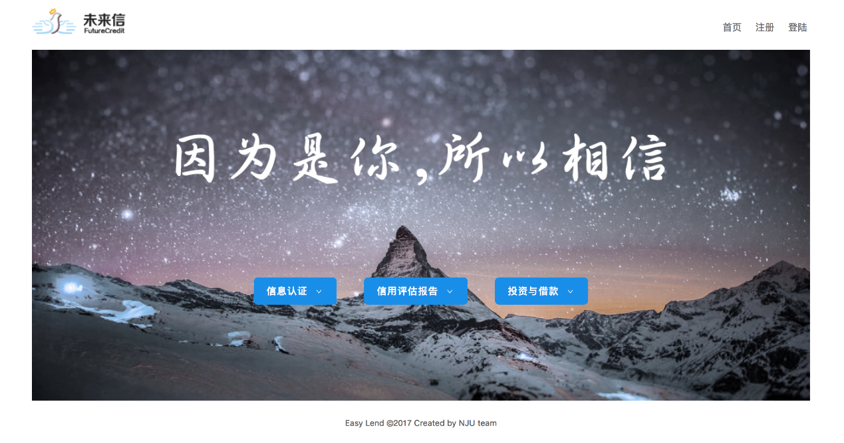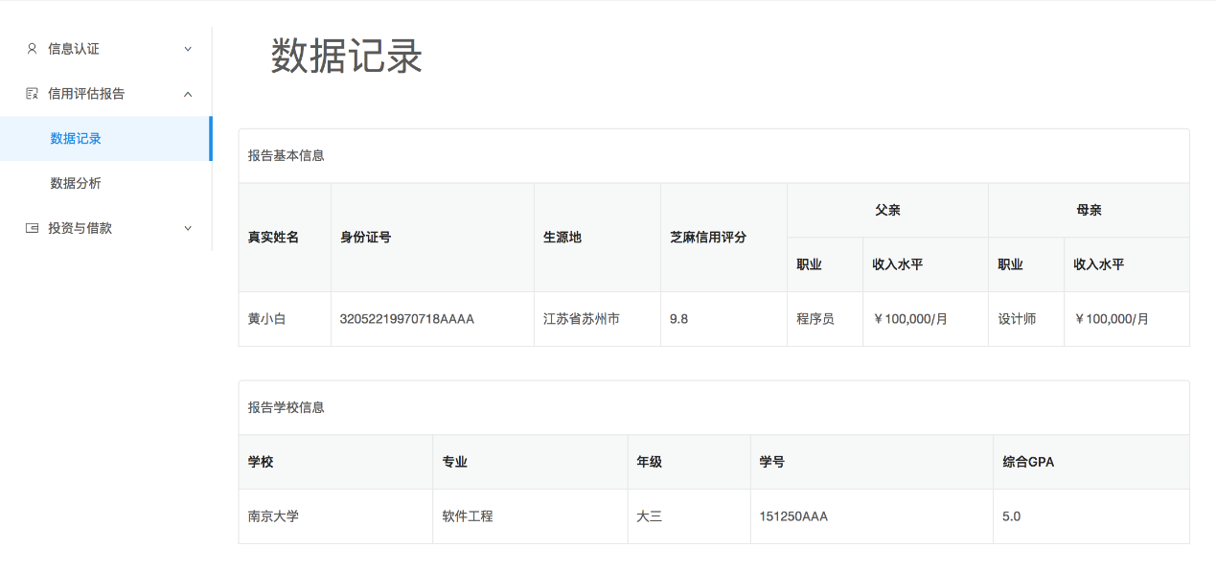

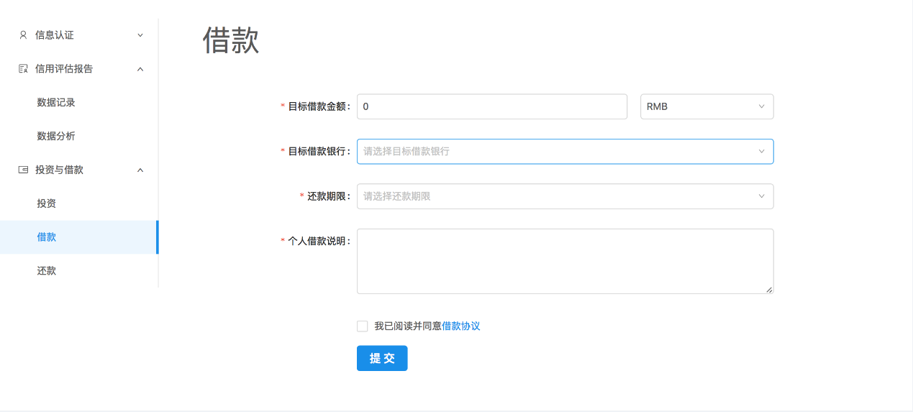

## 4.3 functions

### 4.3.1. Information authentication

Users can choose the form of authentication, each certification, the user credit will be increased in turn, more accurate and comprehensive information, will increase the user credit. All-round display of personal information, designed for users and banks and investors to college students more accurate credit report.

A. Basic information authentication

Users can upload ID card positive and negative photos, fill in parental names, occupation, and work

B. ICBC Account Binding

This requires a user's bank card to bind the phone, verify the user's bank card with the phone number verification code and bind

C. school educational network certification

Enter the educational network account, and password, such as fill in the correct, the user can complete the school educational network certification

D. Sesame credit certification

Prompt the user system after the sesame certification, the system will get the user information, click on the sesame authorized, landing Alipay, you can complete the sesame credit certification

### 4.3.2 Credit assessment

A. All user authentication information will be recorded and displayed to the user here.

B. According to the user to provide the certification information, through the system to build the evaluation model gives the user's assessment. Graphical display of user consumption, default probability.

4.3.3 investment, borrowing

Work with other platforms to promote safer student investment and lending activities based on more effective credit certification.

## 4.4 Technical risk

Technical risk refers to that due to technical failure, such as network interruption, the server crash, the user's borrowing, repayment and other functions cannot operate normally, effectively or smooth, so as to bring credit or money losses. In this regard, the software is willing to bear the risk caused by technical failure. At the same time, we also apply certain preventive measures for the foreseeable technical risks. For example, when meeting network interruption, the system will prompt the user network interrupt, launch reconnection request, and cancel the function the user is currently executing. Account security is also taken into account to protect the user's account security by preventing the disclosure of user information. With regard to the user's password, we make all md5 encryption stored in the service, to protect the user account security to the largest extent.

# 5. Product SWOT analysis

## 5.1 Overview of SWOT methods

In a decision analysis scenario, the most commonly used analysis tool is SWOT analysis. The purpose of SWOT analysis is to analyze the strengths and weaknesses of an enterprise and the opportunities and threats faced by the entire competitive environment. Opportunities and threats are highly relevant to the environmental factors that companies need to consider when making decisions. Opportunities represent favorable environmental factors, and environmental factors that threaten the business are likely to cause damage to the business and are therefore considered.

According to the SWOT matrix, four strategic options can be obtained by matching the advantages, disadvantages, opportunities and threats. SO strategy refers to the use of their own advantages to take full advantage of the opportunity in the environment; WO strategy refers to the enterprise to seize the external opportunities at the same time, gradually weaken the internal disadvantages. Similarly, ST strategy refers to the enterprise to take full advantage of their own competitive advantage to deal with the threat of the environment; WT strategy is to reduce their own disadvantages to cope with the threat of the environment.

Chart 1 SWOT Matrix

|  |  |  |
| --- | --- | --- |
|  | Strength（S） | Weakness（W） |
| Opportunity（O） | SO strategy | WO strategy |
| Threat（T） | ST strategy | WT strategy |

## 5.2 This product SWOT analysis

### 5.2.1 Strength

* New consumption patterns。As a credit rating product of a docking financial institution, the product can calculate the corresponding loan amount according to the credit rating. This product is simple, fast and efficient, to avoid the complex procedures of traditional financial institutions, as well as multi-stage installment options, with strong liquidity.
* For college students。Based on the student identity and the full understanding of the credit characteristics of college students, the team established a sound credit rating system for college students on campus. Compared with the bank credit card and Internet staging loan platform, on the one hand, this product strengthens the credit evaluation and real-time follow-up in the loan before loan, on the other hand, it can effectively meet the strong consumer demand of college students.

### 5.2.2Weakness

* Covering colleges and universities less.

Product pilot colleges and universities for the Nanjing University, only full-time students can apply for it . So the project is facing a potential problem of incomplete business object.

* Credit rating agencies are generally small, business income is not high.

From the 85 national credit rating agency survey results, 45 credit rating company rating business income is less than one million, accounting for 54.92% of the sample survey.

### 5.2.3Opportunity

* Fit the national credit system development plan.

At present, the state is aware of the importance of credit rating for college students' borrowing, and actively supports commercial banks and policy banks to develop relevant financial products and standardize the credit market for college students. Industrial and Commercial Bank of China as a school bank of Nanjing University, is exploring and carry out the relevant financial pilot services.

* The credit evaluation system for college students is still in the early stages of development. At present, all kinds of credit rating system in the market are endless, but the credit score of college students is very small, which also shows that its potential is huge. The targeted credit evaluation system can gradually cultivate college students on time repayment and reasonable regulation of personal property awareness, as a good transition for undergraters to society.

### 5.2.4Threats

* Facing the competition of credit products and credit rating agencies.

Although the Ministry of Education has a relevant notice to encourage banks to college students small loans, but the current chanting and other credit products in the use of college students among the group is still very high, while the credit evaluation system has been very mature. And for the Chinese banks have a small loan function of the Bank of China and China Construction Bank, its own credit evaluation system in the industry's competitiveness is self-evident.

## 5.3 The Countermeasure of Perfecting the Credit Rating System of University Students' Credit

### 5.3.1Establish a sound network loan supervision system

With the introduction of various types of network loan management methods, the information on the platform becomes more authenticity, open and transparent. Net loan industry can not do without credit, for college students net loan is so At present, we should improve the accuracy of product network credit rating, reasonable classification of white list and blacklist, so as to strengthen the awareness of college students credit for the entire network of students to create a good credit economic environment.

### 5.3.2 User review and evaluation

In the analysis of large credit data, before releasing a loan there is need doing the qualifications of a more rigorous review for product users, and thus more reasonable allocation of the loan amount. In the loan there is need launching real-time detection through the user's consumption path, so that the cooperative bank can grasp the flow of funds and credit scores of credit college students to assess the ability to repay, to take measures to ensure risk control.

### 5.3.3Gradually expand the university customer base

As the Industrial and Commercial Bank of China with good reputation, deep background, so after the success of the pilot project we plan to gradually with the Industrial and Commercial Bank and the relevant business cooperation, expand the university customer base, and promote more and more students to use a reasonable campus credit Borrowing and spending.

# 6. Market Expectation

According to the Ministry of Education issued the "China Higher Education Quality Report", the number of Chinese college students in 2015 reached 37 million, the world's first, the national colleges and universities reached 2852, ranking second in the world.

According to the research of China's campus market alliance, the size of the consumer market in China in 2015 will exceed 400 billion. The total size of the Chinese university students' consumer market in 2016 is 685 billion yuan, and the momentum is good. Among them, the daily life as an important part of the consumer market, the total size of 498 billion yuan, college students on average monthly cost of 1423 yuan, in addition to education and training, entertainment, digital products and other consumer spending, 705.8 yuan, Engel coefficient of 32%, has reached the level of wealth.

Among the many factors that affect the choice of college students' consumption, the quality, price and reputation of the product are equally important. The friend's recommendation, social media and platform push constitute the product information source. The consumption of Chinese college students with distinctive Internet and technology genes, including the impact of the Internet media, with the Internet for consumption, Internet content consumption. There are two major differences in the consumption of Chinese college students on the geographical and educational background. Part-time job, bonus and loan finance are the three major sources of consumption except family support.

　　With the rapid development of Internet consumption finance and consumption staging, the scale of Internet consumption finance and consumption staging of college students in China is also expanding. It is expected that the scale of Internet consumption and consumption staging of college students in China will increase in 2017, and the scale of college students' consumption staging market is expected to reach nearly 100 billion yuan.

As a result of the school loan and other chaos caused by adverse social impact, according to the CBRC, the Ministry of Education, Human Resources and Social Security Department in June 28, 2017 implementation of the "on the further strengthening of the campus loan management of the notice" (Yin Jian Fa [2017 ] 26) mentioned that any network lending institutions are not allowed to pay loans to college students. So the current demand for consumer finance is still very large and difficult to meet.  
 On the one hand, the consumer finance market, especially the electricity and financial and network finance, has a great market demand for college students as a meat and potatoes, on the other hand, college students do not have a stable source of income, credit quality varies greatly, which causes lack and blank of credit system of college students. Coupled with the policy constraints, some of the areas of consumer finance and platform for the involvement of college students is expected to be impossible. This contradiction is more stimulating the blowout of this demand. The current policy is to suppress this demand, but in the future, the college student loan system will gradually improve and open. In the process of resolving this contradiction, the formation of the credit model and the formation of the credit system are essential and indispensable. It is the necessary means to solve this contradiction. And our products can just promote the settlement of this contradiction and the consumer financial market norms and improve.

At present, some banks have begun to study the loan system and information collection of college students' groups, and the Ministry of Education has encouraged regular commercial banks to set up microcredit loans for college students, which can be seen at present. At present, the demand for the construction of credit system for college students will become more and more urgent. Our products will be in the future consumer financial platform and financial intermediaries and college students docking process in the process of pivotal. It can be seen that if we can evaluate the credit of college students reasonably and effectively, and reduce the corresponding risks, our products in the future value and development potential should not be overlooked.

# 7. Financial Forecast and Profit Analysis

## 7.1 Profit model

Our project's profit model mainly has the following three kinds:

1. Sell software to some regular financial institutions such as commercial banks.

2. Cooperrate and dock with commercial banks and other financial institutions, signed an agreement, from which a fee.

3. Charge from the ad.

## 7.2 Major financial assumptions

Our company is located in Xianlin campus of Nanjing University, according to 【National Tax [2010] No. 157】, enjoy the exemption from corporate income tax for two years, after three years to reduce corporate income tax; five years after the [National Corfu [2008] No. 172 (2008) No. 362), which is a high-tech enterprise, according to Article 28 of the Enterprise Income Tax Law, Article 93 of the Implementing Regulations of the Enterprise Income Tax Law, Guo Shui Han [2009] No. 203, Key support of high-tech enterprises by 15% corporate income tax levied.

Company office equipment by 10 years depreciation; intangible assets in accordance with 10 years amortization.

The company has no inventory, regardless of the choice of pricing method.

As the company is in the early stages of development, high-speed development stage, temporarily dividends.

According to the actual basis, capacity, potential and business development plan and feasibility of the Company, through the analysis and research, in accordance with the principle of truth-seeking and sound, and follow our current laws, regulations and systems, and consistent with the Ministry of Finance promulgated the enterprise accounting system as well as the revised Accounting Standards for Business Enterprises.

The structure of the Company's share capital is as follows:

Table 7.1-1 Capital Struction

|  |  |  |  |
| --- | --- | --- | --- |
| Capital Struction | | | |
| Source of equity | The team | | Foreign investment |
| Amount of money | 800000（Technology shares） | 400000（Capital shares） | 800000（Capital shares） |
| Propotion | 40% | 20% | 40% |

Image 7.1 Capital Struction

## 7.3 Project Initial Capital Demand Forecast

1. The start-up cost

Table 7.3-1 The starting cost

|  |  |
| --- | --- |
| The start-up cost | |
| Construction staff salaries | 80000 |
| Office expenses | 10000 |
| training fee | 4000 |
| Travel expenses | 10000 |
| Printing fee | 1000 |
| Enterprise registration notarization fee | 40000 |
| Total | 145000 |

1. Fixed assets

Table 7.3-2 Fixed assets

|  |  |
| --- | --- |
| Fixed assets | |
| Server | 100000 |
| Office furniture, decoration | 10000 |
| Computer | 100000 |
| Network equipment | 100000 |
| Printer, air conditioning, fax machine | 30000 |
| Other devices | 10000 |
| Total | 350000 |

1. Other fee

Table 7.3-3 Other fee

|  |  |
| --- | --- |
| Other fee | |
| Initial public relations fee | 50000 |
| Office rental fee | 20000 |
| Renovation costs | 30000 |
| Total | 100000 |

## 7.4 Finance prediction

As a new company, we do not have historical data as a reference, there are few enterprises to learn from, so we rely on the potential market forecast and some similar business enterprises to analyze the relevant data, statistics and other methods Calculation.

**Income forecast**

The potential users of this product are regular financial institutions that are designed to provide microcredit to college students.

In the early period we mainly in the first profit model (sold to the formal financial institutions), can quickly open and occupy the market, the product market price is 100000 yuan / year, including software maintenance costs 10,000 yuan / year. Our plan is the first year in a university pilot, and to some formal commercial banks to sell, the next few years to expand to other universities and further increase the amount of customers.

Table 7.4-1 Five years income forecast

|  |  |  |  |  |  |
| --- | --- | --- | --- | --- | --- |
| Five years income forecast | | | | | |
|  | first year | second year | third year | fourth year | Fifth year |
| Number of clients | 6 | 12 | 25 | 40 | 45 |
| Revence | 600000 | 1200000 | 2500000 | 4000000 | 4500000 |

No non-operating income.

**Operating cost**

Table 7.4-2 Operating cost forecast

|  |  |  |  |  |  |
| --- | --- | --- | --- | --- | --- |
| Operating cost forecast | | | | | |
|  | first year | second year | third year | fourth year | Fifth year |
| Wage | 500000 | 600000 | 650000 | 720000 | 800000 |
| Depreciation of fixed assets | 35000 | 35000 | 35000 | 35000 | 35000 |
| Total | 535000 | 635000 | 685000 | 755000 | 835000 |

Wages include technical maintenance staff salaries and market maintenance staff salaries, with the number of customers increased, the corresponding number of maintenance personnel and wages will be increased accordingly；

Depreciation of fixed assets is as follows：

The total value of fixed assets：350000

Estimated useful life：10年 Estimated residual value：0

Depreciation is calculated using the straight-line method：（350000-0）/10=35000

No non-operating cost。

**Sales Expense**

Table 7.4-3 Selling Expense

|  |  |  |  |  |  |
| --- | --- | --- | --- | --- | --- |
| Selling Expense | | | | | |
|  | first year | second year | third year | fourth year | Fifth year |
| Sales staff salaries | 100000 | 150000 | 200000 | 210000 | 220000 |
| Sales staff travel expenses | 5000 | 8000 | 10000 | 10000 | 10000 |
| Total | 105000 | 158000 | 210000 | 220000 | 230000 |

Description：

In the first two years, due to the expansion of business needs, need to increase the number of slightly sold staff, starting from the third year, due to the particularity of the product, without too many sales staff, so in addition to increasing wages, no longer increase the number of sales staff.

**Management costs**

Table 7.4-4 Management cost

|  |  |  |  |  |  |
| --- | --- | --- | --- | --- | --- |
| Management cost | | | | | |
|  | first year | second year | third year | fourth year | Fifth year |
| Management salaries | 200000 | 240000 | 240000 | 240000 | 240000 |
| Welfare fee | 4000 | 8000 | 12000 | 16000 | 20000 |
| Office expenses | 10000 | 10000 | 10000 | 10000 | 10000 |
| Water and electricity | 20000 | 20000 | 20000 | 20000 | 20000 |
| Training fee | 10000 | 15000 | 20000 | 25000 | 30000 |
| Start - up amortization | 53000 | 53000 | 53000 | 53000 | 53000 |
| Amortization of intangible assets | 80000 | 80000 | 80000 | 80000 | 80000 |
| Total | 377000 | 426000 | 435000 | 444000 | 453000 |

Description: management staff 4, because managers have ownership, so lower wages.

## 7.5 Forecast of income statement

Based on the above estimates, the profit and loss of the Company is expected to be as follows：

Table 7.5 Forecast of income statement

|  |  |  |  |  |  |
| --- | --- | --- | --- | --- | --- |
| Forecast of income statement | | | | | |
|  | first year | second year | third year | fourth year | Fifth year |
| Revence | 600000 | 1200000 | 2500000 | 4000000 | 4500000 |
| Less: Cost of Sales | 535000 | 635000 | 685000 | 755000 | 835000 |
| Selling expense | 105000 | 158000 | 210000 | 220000 | 230000 |
| G&A expense | 377000 | 426000 | 435000 | 444000 | 453000 |
| Finance expense | 0 | 0 | 0 | 0 | 0 |
| Gross Profit | -417000 | -19000 | 1170000 | 2581000 | 2982000 |
| Add：Non-operating income | 0 | 0 | 0 | 0 | 0 |
| Less: Non-operating expense | 0 | 0 | 0 | 0 | 0 |
| Profit before Tax | -417000 | -19000 | 1170000 | 2581000 | 2982000 |
| Less: Income tax | 0 | 0 | 146250 | 322625 | 372750 |
| Net profit | -417000 | -19000 | 1023750 | 2258375 | 2609250 |

Note: Financial expenses are assumed to be 0;

Income tax rate of 25%, no non-operating income and expenditure.

## 7.6 Forecast cash flow statement

The cash flow of the Company is expected to be as follows：

Table 7.6 Forecast cash flow statement

|  |  |  |  |  |  |
| --- | --- | --- | --- | --- | --- |
| Forecast cash flow statement | | | | | |
|  | first year | second year | third year | fourth year | Fifth year |
| Cash received from sales of goods or rendering of services | 600000 | 1200000 | 2500000 | 4000000 | 4500000 |
| Tax Refund | 0 | 0 | 0 | 0 | 0 |
| Other cash received relating to operating activities | 0 | 0 | 0 | 0 | 0 |
| Sub-total of cash inflows | 600000 | 1200000 | 2500000 | 4000000 | 4500000 |
| Purchase of goods, cash paid for payment of labor services | 30000 | 30000 | 30000 | 30000 | 30000 |
| Payment to employees and cash paid for employees | 899000 | 1096000 | 1212000 | 1286000 | 1370000 |
| Pay the taxes | 0 | 0 | 146250 | 322625 | 372750 |
| Payment of other cash related to operating activities | 40000 | 45000 | 50000 | 55000 | 60000 |
| Cash outflow sub-total | 969000 | 1171000 | 1292000 | 1371000 | 1460000 |
| Net cash flow from operating activities | -369000 | 29000 | 1208000 | 2629000 | 3040000 |

## 7.7 DuPont analysis

Return on net assets (ROE) = net profit / shareholders' equity

= (Net profit / total assets) × (total assets / shareholders' equity)

= Total return on assets (ROA) × equity multiplier

= Net profit margin (NPM) × total asset turnover (AU) × equity multiplier (EM)

Return on net assets is the starting point and core of the entire analysis system, reflecting the size of the investor's net assets profitability. Return on net assets is determined by the net profit margin, total asset turnover and equity multiplier. The net profit margin reflects the profitability of sales revenue, which reflects the profitability of the company. The total asset turnover reflects the comprehensive ability of the enterprise assets to realize the sales revenue, which reflects the company's operating ability. The equity multiplier reflects the degree of the company's use of financial leverage to carry out the business activities, which reflects the company’s solvency. Changes in the three indicators together led to changes in the return on net assets.